Sounds of Poetry

You will be creating 4 separate projects (files) in GarageBand.
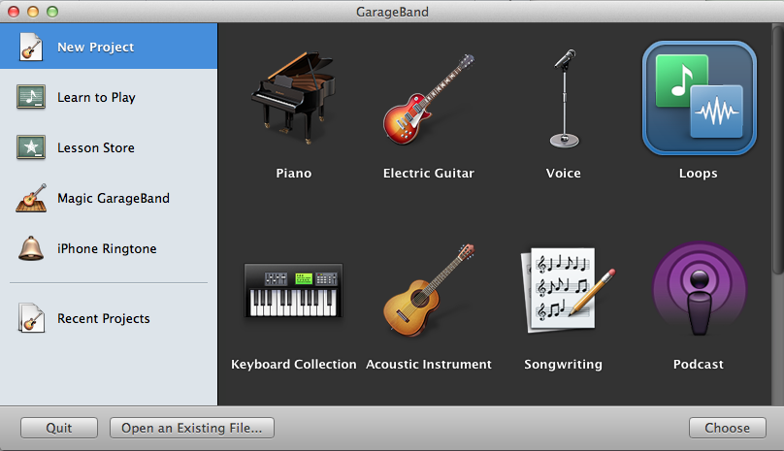
Open GarageBand and create a new project using loops.

You will be saving each file as different file name according
to which element of your podcast you’re working on.

Poetry Intro: 5 measures of music.
This will be used at the beginning of your podcast. It should introduce the overall “feel” of the poet you chose.

Poetry Transition: 3 measures of music.
This will be used in between segments on your podcast. Look at using some of the sound effects to create this element.

Poetry Outro: 7 measures of music.
This will be used at the very end of your podcast. It should wrap up your presentation and have a final ending to your podcast.

Poetry Music: at least 20 measures of music.
You will use this music to play in the background while you read your poems on the podcast. It should match the “feeling” of the poems you chose (happy, sad, love, exciting, etc.).
If you want different music for each poem,
you may create a separate project/file for each.

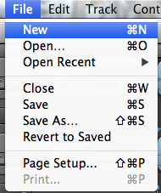
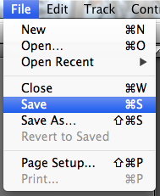
When you finish each element you will save by
clicking “File” then “Save” or [command] + [s]

Then you will start your next project by clicking
“File” then “New” or [command] + [n]

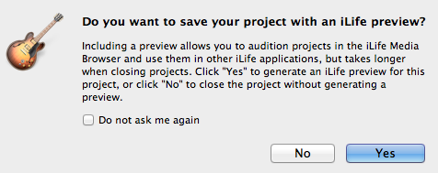
GarageBand will then ask you if you
want to save your project with an
iLife preview and you click “Yes”.

