(Why are we doing this? Why is this important?)

Schedule of Events

Doors open at 5:30

**Artisan Craft Fair**

**Scholastic Book Fair**

5:30-8:30

**Ethnic Food Fare**

5:30-7:30

**Band & Choir Concerts**

7:00-8:30



All Food & Bowl Proceeds Benefit

**Emergency Food Shelf Network**

http://www.emergencyfoodshelf.org

THANK YOU

Sponsors

**RBC Wealth Management**

<http://www.rbcwealthmanagement.com>

**Minneapolis Aquatennial**

<http://www.aquatennial.com>

**Bryn Mawr Bugle**

<http://www.bmna.org/bugle.html>

**Cub Foods**: Crystal, MN

<http://www.cub.com>

**Thank you for your donation to Anwatin’s Empty Bowl Event**

**Amount: $__________**

**Signature of Anwatin Staff:**

(Info about Empty Bowls)

Taste

of Anwatin

An All-School International Celebration of Culture, Arts, Service and Learning

Welcome!

¡Bienvenidos!

Bienvenue!

歓迎

Presented By:

RBC Wealth Management

<http://www.rbcwealthmanagement.com>

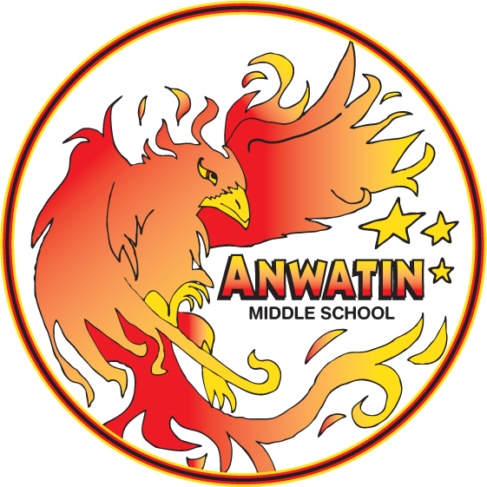

**December 4th**

**2014**

Hunger in the World

Hunger in Minnesota

Hunger in the U.S.A

Your Facts and Pictures

Your Facts and Pictures

Your Facts and Pictures